**Wishbone Loads Stress Analysis**

Every part of a race car should be optimised and justified using stress analysis, this includes the wishbones.

**What Are Wishbones?**

**Longitudinal-** **parallel to the direction of travel**

**Lateral- sideways**

A wishbone is the most common type of A-arm (also called control arms). A-arms are a key component of the suspension system which serve as a direct connection point between the chassis (skeleton of car which all other components are attached onto) and the wheel hub (part at centre of wheel which keeps the wheel in place and uses bearings for smooth wheel rotation). A-arms keep the wheels aligned with the rest of the car and keep the wheel in contact with the ground (very important for safety and stability).

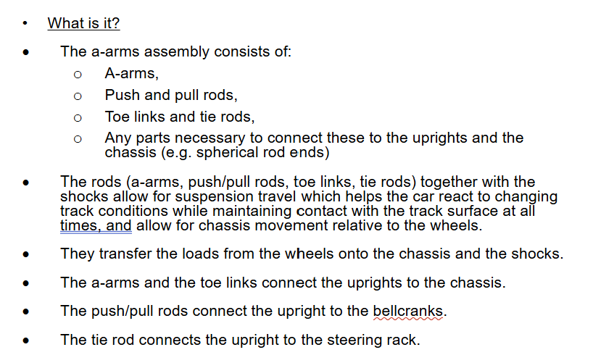

A double-wishbone setup is made up of two wishbone-shaped arms connected to the wheel hub through an upright/knuckle. One a-arm is connected at the top and another at the bottom, with a damper attached to the bottom a-arm in most cases. Compared to some other a-arms, the wishbone setup design and geometry allows better contact with ground and prevents negative camber (wheels tilting inward) which causes less tyre wear.

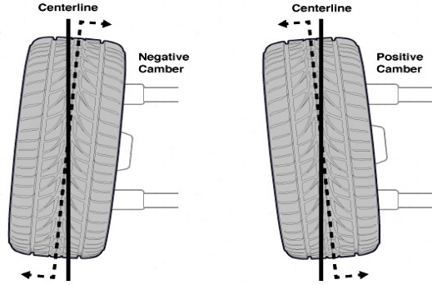

The damper/shock absorber absorbs energy from bumps/uneven roads without compromising the contact patch with the ground, resulting in a car that’s more comfortable and less shaky on bumpier roads. Wishbones offer greater control over camber, caster (how far forward or behind the steering axis is to the vertical axis) and roll centre (The roll center of a car is a point/line in the car’s suspension system where the car’s body rotation occurs during cornering).

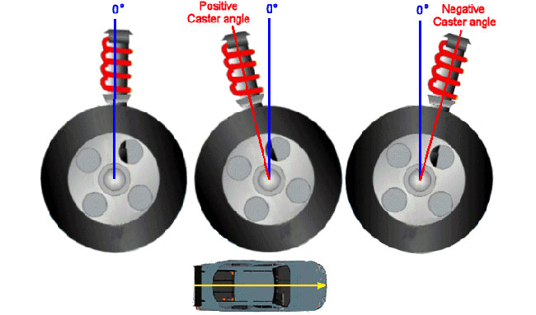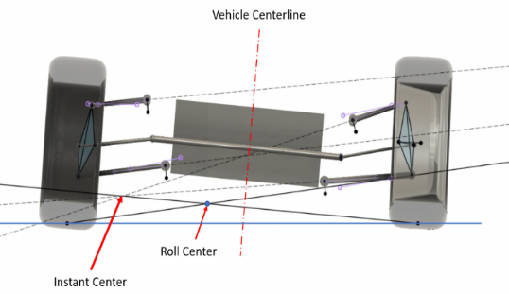

A double wishbone system allows less vertical space to taken up (lowering centre of gravity, allowing better handling).

Double wishbone offers overall better performance in most formula racing scenarios, but it does cost more. The wishbone system has more components and requires more parts to be maintained, therefore increasing service costs. The wishbone system takes up more horizontal room, possibly widening the car which reduces aerodynamics.

[What Is Double Wishbone Suspension, And Is It Superior? | News | CarThrottle](https://www.carthrottle.com/news/what-actually-double-wishbone-suspension)

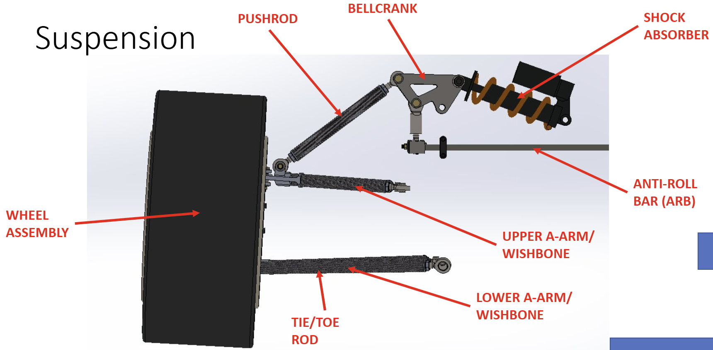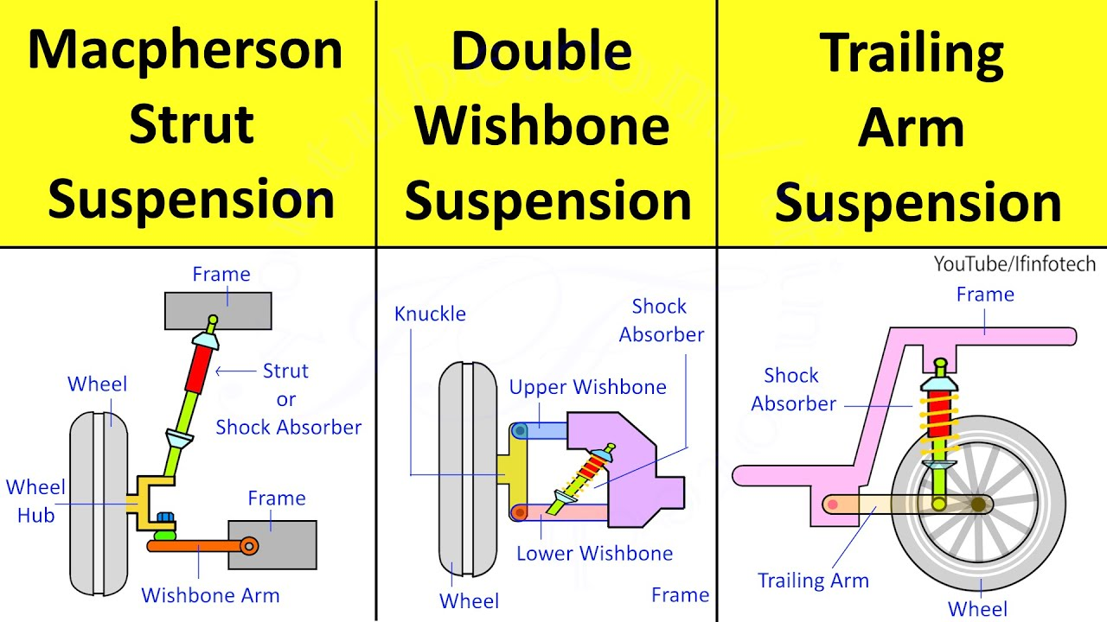

The wishbones move vertically, helping to absorb shocks from the road by allowing the wheel to move up and down and adapt to road conditions.

**Important Numbers/Terms Used**

The loads on the wheels at their points of contact from forces must be analysed to see what forces the wishbones must deal with. This must be done for the front and rear at their respective critical load cases. This document will show the wishbone loads for each scenario even if they aren’t critical.

Front suspension critical load cases are maximum vertical load, braking, cornering.

Rear suspension critical load cases are maximum vertical load, braking, cornering, maximum acceleration.

Lateral (sideways of wheel) and longitudal (forward of wheel) load transfer causes the load experienced by the wishbones to increase or decrease depending on the scenario. Longitudal load transfer would be: accelerating which puts more load on back wheels, breaking putting more load on front wheels. Lateral load transefer would be: cornering putting more load on outward wheels due to ’centrifugal force’ (more like all car parts wanting to remain going current velocity but direction is changing).

Aerodynamic downforce is when high-pressure slow-moving air pushes down the car due to low-pressure fast-moving air being below the car, lowering the centre of mass and increasing grip (which is good for making the car move faster and more efficiently without extra mass). However, downforce also increases the load on wishbones/wheels, so when the car is moving downforce must be accounted for in equations and added to the static weight. For a car with very high levels of downforce (like an f1 car), a value of 3.3 is recognised (according to pg 25 of ‘race car design’ by derek seward) as the maximum downforce multiplication factor and is multiplied by weight to find downforce D=Wxmaximum downforce multiplication factor

When a car goes over a bump or into the air, the weight loads experienced by each wheel drastically change. These loads are called shock loads and are transmitted through the suspension and dampers at a high increase of load over a short duration. The exact magnitude of these dynamic shock loads drastically alter depending on the situation and are hard to calculate exactly. It is common practice to apply ‘dynamic multiplication factors’ to the static loads to account for these shock loads and extra stresses. The suggested dynamic multiplication factors for some suspension load cases are:

For maximum cornering- DMF of 1.3 used on vertical and lateral loads

For maximum breaking- DMF of 1.3 used on vertical and longitudinal loads

For maximum acceleration- DMF of 1.3 used on vertical and longitudinal loads

For the maximum vertical load- DMF of 3 used on vertical loads (effectively increasing weight by 3)

For the maximum downforce- DMF of 1.3 used on vertical loads (downforce already only happens during movement, but shock vertical loads which occur while downforce is acting downward further increase the load experienced due to downforce and must be accounted for)

Structural engineers consider the likelihood of two of the same maximum load cases occurring at the same time very low, with each case having a lower DMF in the combination, meaning combined cases are usually not critical or greater than critical load case and therefore are not really considered.

To demonstrate these formulas, consider a car with parameters:

Weight=mg=7350N

(Where m=total mass (sprung & un-sprung) including driver and downforce [kg])

Friction coefficient assumed to be 1.2 at high velocities, 1.5 for at low velocities (due to tyre sensitivity). Just check ive explained this later on

Max dynamic multiplication factors used in order to find critical loads to ensure that the car can withstand all possible forces.

Maximum Vertical Loads-For Centre of Mass In middle of car

Front wheel- maximum vertical load

(NOTE: in ‘race car design’ by derek seward, pg 89 example 3.2 part a, it uses 27710N in place of 26790N by accident-this is a typo as proven by doing the calculation).

To find the maximum vertical load the car must be considered under maximum downforce at maximum possible vertical load in movement.

Design vertical load = (W x max vertical load dmf) + (W x max downforce multiplication factor x max downforce dmf) aerodynamic maximum dynamic multiplication factor -is this what it should be called instead, check book but I think yes

Design vertical load = (3xW)+(Wx3.3x1.3)

(Where downforce=Wx3.3)

Design vertical load = (3x7350)+(7350x3.3x1.3)

Design vertical load =22050+31531.5

Design vertical load =53581.5N

Design load just means it is the load the wishbone must be designed to withstand.

This maximum vertical load is halved to find the value per side of the car(split down the middle).

Design vertical load per side of car (left/right side)=0.5x53581.5

Design vertical load per side of car (left/right side)=26790.75N

This value per side of the car is then scaled by the load the front wheel must bear due to the distances of the front and rear axles(rod connecting the same pair of wheels to another) from the centre of mass, giving the value per singular front wheel.

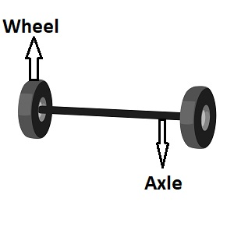

The further the axle from the centre of mass, the less weight the wheels take on, so by finding how far the back axle is from the centre of mass divided by the wheelbase (entire distance between the front and back wheel), the load the front wheels must bear due to how far away the rear axle is can be found by the ratio (L-lm)/l multiplied by the design vertical load per side of car.

Design vertical load of one front wheel (Wfvert)=design vertical load per side of car x (L-lm)/L

L = wheelbase [mm]

Wheelbase is the length of the car from front wheel contact point (front wheel hub) to rear contact point (rear wheel hub).

lm= shortest distance between front axle (connector of two wheels which holds weight of car and rotates to allow for steering) and centre of mass [mm]

Design vertical load of one front wheel (Wfvert) = 26790.75 x (3215-1950)/3215)

Design vertical load of one front wheel (Wfvert) = 10541N

Rear wheel- maximum vertical load

Rear wheel maximum vertical load can be calculated in basically the same way, but we can skip a lot of steps since we have already calculated the design vertical load per side of car and design vertical load of one front wheel:

Design vertical load per side of car=26790.75N

Design vertical load of one front wheel (Wfvert) = 10541N

The remaining vertical load not taken on by the front wheel must be taken by the rear wheel. Therefore:

Design vertical load of one rear wheel (Wrvert)= Design vertical load per side of car - Wfvert

Design vertical load of one rear wheel (Wrvert)= 26790.75-10541N

Design vertical load of one rear wheel (Wrvert)= 16249N

Maximum breaking loads

Front wheel - maximum braking (critical case)

The effective total weight of car while moving is the result of its static weight and downforce:

Effective total weight of car (WT)= static weight + downforce

Effective total weight of car (WT)= W + D

Effective total weight of car (WT)= 7350 + (7350x3.3)

Effective total weight of car (WT)= 7350 + 24255

Effective total weight of car (WT)= 31605N

Like in the maximum vertical loads case, the vertical load the front wheels/axle must bear is dependant on the distance of the opposite axle from the centre of mass, calculated by the ratio of the rear axle from the centre of mass for the front axle:

Front axle vertical load (WF)= WT x (L-lm)/L

Front axle vertical load (WF)= 31605x(3215-1950/3215)

Front axle vertical load (WF)= 12436N

Apart from manual braking, the car will also experience other forces which cause it decrease in speed as soon as the driver lifts off the throttle during breaking such as air friction and friction from the ground (car will slow by 1.5g before breaks are touched). These breaking forces are applied at the centre of pressure on the front of the car (not at road level). The maximum load we care about for the wishbones is experienced at the tyres, so these forces are therefore not included in the calculations as they stress. The changes air friction and ground friction cause are very small and can be considered nehgligable also.

The force produced at the tyres due to breaking of the vehicle is found by: 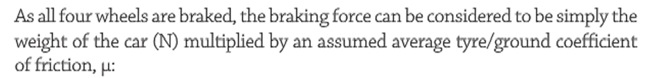

Braking force (F)= WT x u

Where u= tyre maximum friction coefficient, race car design tells us to assume a range of 1.4-1.6, but is 1.2 for the front tyres in this example as due to an increase in vertical loads, downforce and weight transfers while moving causing the tyre sensitivity to decreases. How doe s this ecxplain the decrese idot



Braking force (F)=31605x1.2

Braking force (F)=37926N

When breaking, everything will want to keep moving forward therefore the car will dive forward with more weight being shifted to the front of the car.

Longitudinal weight transfer (deltaWx)=+-(FxHm)/L

Hm= height of centre of mass from the surface of the road [mm]

Longitudinal weight transfer (deltaWx)=+-(37926x325)/3215

Longitudinal weight transfer (deltaWx)=+-3834N

By adding the front axle load to the extra load experienced due to longitudinal caused weight transfer, the total weight experienced by the front axle can be found. Then by dividing by two, the load per front wheel can be found.

Front wheel vertical loads (individual wheel)=(WF+deltaWx)/2

Front wheel vertical loads (individual wheel)=(12436+3834)/2

Front wheel vertical loads (individual wheel)=8135N

Max breaking dynamic multiplication factor is then multiplied against static vertical loads as vehicle is in motion.

Design vertical load for one front wheel (Wfvert)= 8135x1.3

Design vertical load for one front wheel (Wfvert)=10576N

Then to find braking force required longitudinally, the design load vertical is multiplied by the friction coefficient to find the force exerted on the wishbones/wheels individually while the vehicle is in motion this time.

Design longitudinal brake force for one front wheel (Wflong)= Wvert x u

Design longitudinal brake force for one front wheel (Wflong)= 10576x1.2

Design longitudinal brake force for one front wheel (Wflong)= 12691N

Rear wheel - maximum braking

Rear wheel maximum breaking loads can be found in the same way, with just a different weight ratio on wheels:

Rear axle vertical load (WR)= WT x lm/L

Rear axle vertical load (WR)= 31605x1950/3215

Rear axle vertical load (WR)= 19169N

Longitudinal weight transfer takes weight off the rar wheels during breaking.

Rear wheel vertical loads (individual wheel)=(WR-deltaWx)/2

Rear wheel vertical loads (individual wheel)=(19169-3834)/2

Rear wheel vertical loads (individual wheel)=7668N

Design vertical load for one rear wheel (Wrvert)= 7668x1.3

Design vertical load for one rear wheel (Wrvert)=9968N

Design longitudinal brake force for one rear wheel (Wrlong)= Wrvert x u

Design longitudinal brake force for one rear wheel (Wrlong)= 9968x1.2

Design longitudinal brake force for one rear wheel (Wrlong)= 11962N

Front Wheel- Maximum cornering Pg31 and ph90?

As worked out previously:

Effective total weight of car (WT)= static weight + downforce

Effective total weight of car (WT)= W + D

Effective total weight of car (WT)= 7350 + (7350x3.3)

Effective total weight of car (WT)= 7350 + 24255

Effective total weight of car (WT)= 31605N

Braking force (F)= WT x u

Where u= tyre maximum friction coefficient, assumed to be in the range of 1.4-1.6, but is 1.2 for the front tyres in this example as due to high speeds the tyre sensitivity decreases

Braking force (F)=31605x1.2

Braking force (F)=37926N

Since the car is cornering, lateral weight transfer is now experienced by the tyres instead of the longitudal ones experienced when braking/accelerating. The load on the outer tyres increases by a certain amount while the load on the inside decreases by that same amount. The formula works the same as the longitudinal weight transfer but uses T instead of L.

Total lateral weight transfer for whole car, (deltaWT)=+-Fhm/T

T=width of the car from left wheel centre point to right wheel centre point(m)

Total lateral weight transfer for whole car, (deltaWT)=+-(37926x325)/1500

Total lateral weight transfer for whole car, (deltaWT)=+-8217N

Vd scary book-weight transfer section lateral weight transfer- centre of gravity is not in middle pg678,

Pg700

Should I set up calculation for calculating individual wheels lateral load transfer as percentage or Is that given?162 cant find it in chapter 7 tho

62.5% of this weight tranfer can be assumed to go to front wheels. This must be added to the effective weight of one front wheel which will be the outer whhel in this scenario.

Front outer vertical wheel load=(0.5xWeffectivex(L-lm)/L)+(deltaWTx0.625)

Front outer vertical wheel load =(0.5x31605x(3215-1950/3215))+(8217x0.625)

Front outer vertical wheel load =11354N

Laterally added to vertical?

Multiply this by maximum cornering DMF

Weight vertical of front outer wheel(Wfovert)=11354x1.3

Weight vertical of front outer wheel(Wfovert)=14760N

This maximum vertical weight multiplied by the friction of the track will describe the maximum load experienced by the wheel laterally(as friction is acting against the turn, therefore pushing against weight laterally). u is 1.2 due to tyre sensitivity decreasing when cornering/at high speed/accelerating

Front outer design cornering force (Wfolat)=Wfovert x u

Front outer design cornering force (Wfolat)=14760x1.2

Front outer design cornering force (Wfolat)=17712N

Inner Front Wheel- Maximum cornering

Lateral weight transfer takes weight off the inner front wheel during cornering.

Front inner vertical wheel load=(0.5xWeffectivex(L-lm)/L)-(deltaWTx0.625)

Front inner vertical wheel load =(0.5x31605x(3215-1950/3215))-(8217x0.625)

Front inner vertical wheel load =1082N

Laterally added to vertical?

Multiply this by maximum cornering DMF

Weight vertical of front inner wheel(Wfivert)=1082x1.3

Weight vertical of front inner wheel(Wfivert)=1407N

This maximum vertical weight multiplied by the friction of the track will describe the maximum load experienced by the wheel laterally(as friction is acting against the turn, therefore pushing against weight laterally). u is 1.2 due to tyre sensitivity decreasing when cornering/at high speed/accelerating

Front inner design cornering force (Wfilat)=Wfivert x u

Front inner design cornering force (Wfilat)=1407x1.2

Front inner design cornering force (Wfilat)=1688N

Inner Rear Wheel- Maximum cornering

Rear outer vertical wheel load=(0.5xWeffectivexlm)/L)+(deltaWTx0.375)

Rear outer vertical wheel load =(0.5x31605x(1950/3215))+(8217x0.375)

Rear outer vertical wheel load =12666N

This is larger than front now? Is this critical case, I just worked it out its not included in book

Multiply this by maximum cornering DMF

Weight vertical of rear outer wheel(Wrovert)=12666x1.3

Weight vertical of rear outer wheel(Wrovert)=16466N

Rear outer design cornering force (Wrolat)=Wvert x u

Rear outer design cornering force (Wrolat)=16466x1.2

Rear outer design cornering force (Wrolat)=19759N

Outer Rear Wheel- Maximum cornering (smaller force experienced)

Lateral weight transfer takes weight off the inner rear wheel during cornering.

Rear inner vertical wheel load=(0.5xWeffectivexlm)/L)-(deltaWTx0.375)

Rear inner vertical wheel load =(0.5x31605x(1950/3215))-(8217x0.375)

Rear inner vertical wheel load =6503N

Multiply this by maximum cornering DMF

Weight vertical of rear inner wheel(Wrivert)=6503x1.3

Weight vertical of rear inner wheel(Wrivert)=8454N

Rear inner design cornering force (Wrilat)=Wvert x u

Rear inner design cornering force (Wrilat)=8454x1.2

Rear inner design cornering force (Wrilat)=10145N

Maximum acceleration - rear wheel (critical case)

Acceleration would be greatest going from stationary to moving (‘off the line’). Therefore, downforce and traction limited acceleration(acceleration limited by the frictional grip that can be generated, without wheelspin) can be considered negligible. A close up of text
does this not just go directly against what I just said.

Let u be friction coefficient of rear tire = 1.5 (as we are not moving very fast, tyre sensitivity is high)

Pg24 -explain why you do each equation AND EXPLAIN MORE

Weight of car(W)=7350N

Static rear axle load(Wr)=Wx(lm/L)

Static rear axle load(Wr)=7350 x(1950/3215)

Static rear axle load(Wr)=4458N

Rear wheel Traction Force(Fr)=(Wr x u)/[1-(hm x u)/L]

Rear wheel Traction Force(Fr)=(4458 x 1.5)/[1-(325 x 1.5)/3215]

Rear wheel Traction Force(Fr)=7882N

Longitudinal load transfer(deltaWx)=+-(Fr x hm)/L

Longitudinal load transfer(deltaWx)=+-(7882x325)/3215

Longitudinal load transfer(deltaWx)=+-787N

Rear wheel loads(Wrl or Wrr)=(Wr+ deltaWx)/2

Rear wheel loads(Wrl or Wrr)=(4458+797)/2

Rear wheel loads(Wrl or Wrr)= 2628N

Multiplied by maximum acceleration dmf

Acceleration design load for one rear wheel(Wrvert)=2628x1.3

Acceleration design load for one rear wheel(Wrvert)= 3416N

Design acceleration force for one rear wheel(Wrlong)=Wrvert x u

Design acceleration force for one rear wheel(Wrlong)=3416 x 1.5

Design acceleration force for one rear wheel(Wrlong)=5124N

Acceleration force is applied to the wishbones via the wheel hub bearings at the mid height of the rear wheel hub, instead of at the tyre contact patch. how ans why does this matter just for vectors?

Maximum acceleration – front wheel?

Static front axle load(Wf)=Wx(L-lm/L)

Static front axle load(Wf)=7350 x(3215-1950/3215)

Static front axle load(Wf)=2892N

How does this come about

Front wheel Traction Force(Ff)=(Wf x u)/[1-(hm x u)/L]

Front wheel Traction Force(Ff)=( (4458 x 1.5)/[1-(325 x 1.5)/3215]

Front wheel Traction Force(Ff)=5113N

Longitudinal load transfer(deltaWx)=+-(F x hm)/L

Longitudinal load transfer(deltaWx)=+-(7882x325)/3215

Longitudinal load transfer(deltaWx)=+-787N not relevant to front wheels? How does this work for two wheel drive?

Front wheels have load transferred off them longitudinally when accelerating.

Front wheel loads(Wfl or Wfr)=(Wr-deltaWx)/2

Front wheel loads(Wfl or Wfr)=(2892-787)/2

Front wheel loads(Wfl or Wfr)=1053N

Multiplied by maximum acceleration dmf

Acceleration design load for one front wheel(Wfvert)=1053x1.3

Acceleration design load for one front wheel(Wfvert)= 1368N

Design acceleration force for one front wheel(Wflong)=Wfvert x u

Design acceleration force for one front wheel(Wflong)=1368 x 1.5

Design acceleration force for one front wheel(Wflong)=2052N

Maximum Vertical Loads-For Centre of Mass not at centre of car

Longitudinal load transfer-each wheel

The wheels on the side of the car with the centre of mass closer to that side experiences a greater proportion of the longitudinal weight transfer than the other side of the car.

The offset ratio(gamma)= y’’/(t/2)

Where y’’ is the centre of gravitys offset from centre position to the side

t=treadwidth

the offset ratio is the preportion of the centre of gravitys offset from centre positoon with respect to half the trackwidth of the vehicle.

Since half track can be different at the fronyt and back of a car, so too will gamma

Y’’ is positive when to the right and negative when to the left

Where Cx is a coefficient that can be mutlipled by axle load tranfer to find CG offset

For front tyre on opposite side to where CG is Cx1 = ½ (1-gammaf)

For front tyre on side where CG is Cx2= ½ (1+gammaf)

For rear tyre on opposite side to where CG is Cx3= ½ (1-gammar)

For rear tyre on side where CG Cx4 = ½ (1-gammar)

The longitudinal load transfer (deltaW)for each wheel can then be represented as:

DeltaW1=-Cx1(W)(h/l)Ax front tyre without CG on side

DeltaW2=-Cx2(W)(h/l)Ax front tyre with CG on side

DeltaW3=+Cx3(W)(h/l)Ax rear tyre without CG on side

DeltaW4=+Cx4(W)(h/l)Ax rear tyre with CG on side

Where Ax is positive for acceleration and negative for breaking (makes equations correct for which direction longitudinal weight transfer is)

Say what each symbol means and which wheel is which

W=weight

Ax= longitudinal acceleration - measure this practically, in g units

l= wheelbase

h=height of CG from ground

Lateral load Transfer-each wheel

H=height of total CG above roll axis

y’’= centre of gravitys offset from centre position to the side, positive when going to right

W=Total vehicle weight

W’ = effective weight due to bank angle and speed

Ay=lateral acceleration, measured in gs

Alpha= angle of bank from floor degrees

KF=total front roll rate in lb.-ft/rad?

KR=total rear roll rate

Aalpha=centrifugal acceleration

V=speed

R=radius of circle being cornered

g=9.8ms-2

tf=front track m

tr=rear track m

b=horizontal distance from rear axle to CG m

l=wheelbase m

ZRF=front roll centre height m

ZRR=rear roll centre height m



Weight transfer from right to left wheel on the front axle

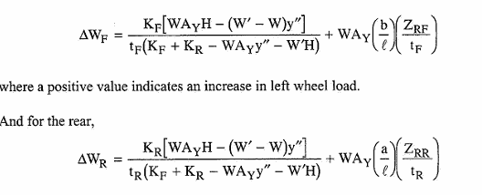

Cornering on banked turn

Effective static weight on each wheel resulting from banking

Worked example

Put this in terms of max loads

Make sure this is usable/see if other calcs needed -banking

Want big traction at off the line acceleration. Minimise effects caused by tyre sensitivity

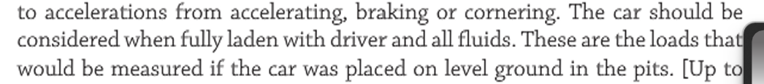

Understand it all.

Owen refer to thing

References for pages correct pages on book

Go over matlab code book e made

Make a model for our car-owns numbers for tyres

Do other matrix method

Github page, wiki page, sharepoint page when done with all files